Burundi visit report.
Hello everyone,
I am so pleased to be able to send you a very positive report from my recent mission visit to Burundi.
God has been so amazing each and every step of the way and I have seen so much evidence of His favour and hand of blessing starting from the moment that I left home in Worthing to the time of my return.
As you know I left the UK on 30th April and arrived in Bujumbura at around 9am on 1st May, where I was met by the YMG team made up of members from Congo & Burundi.
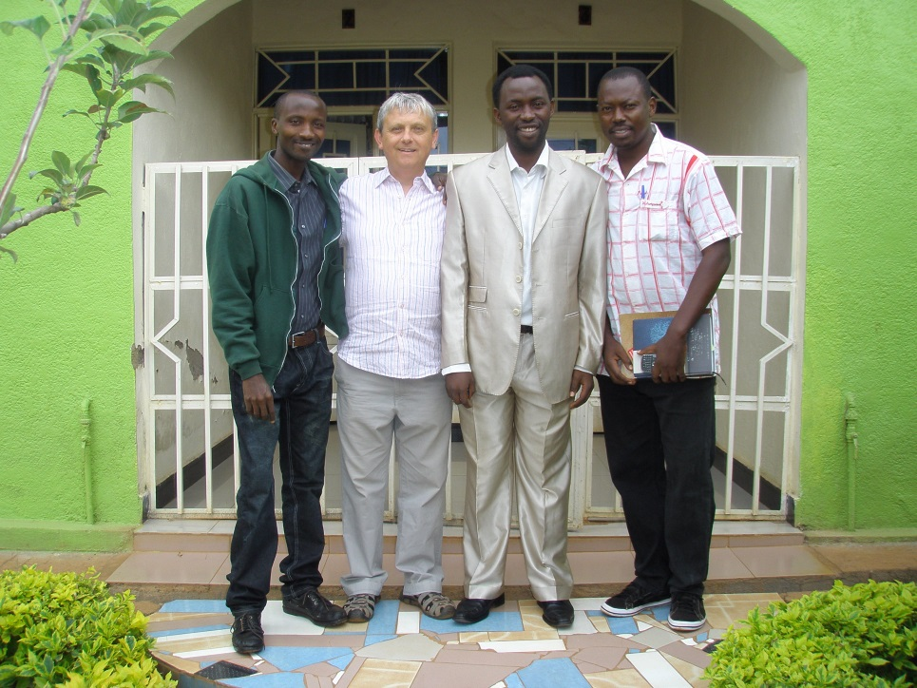
YMG Team (left to right):
Pastor Mathieu (Burundi), Martin B (UK), Bro Mana (Congo) & Bro Edmund (Burundi).
God brought together just the right mix of people, with just the right skills and heart of service and it has been so clear that Jesus was leading us each and every step.
The vision was to take the First Steps discipleship course around 10 of the Northern provinces of Burundi, holding a teaching seminar in each of the provincial towns in order to train Pastors, Evangelists and church teachers in how to use the course, so that they were trained and equipped to take the course back to their own churches to use it as a Bible teaching resource.
The first 2 days were spent in the capital city of Bujumbura, making preparations, checking equipment and training the team.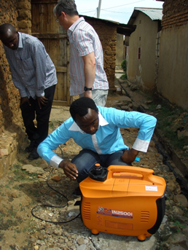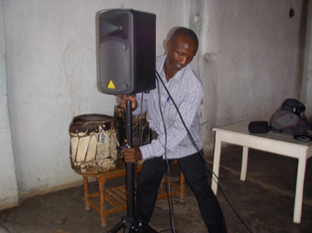
We then set off, just a team of 4 people travelling in 1 vehicle, holding seminars in the provincial towns of each province. We visited all of our targeted towns that we had planned to right through from Bubanza ending up in Muramvya and then back to the capital city of Bujumbura.
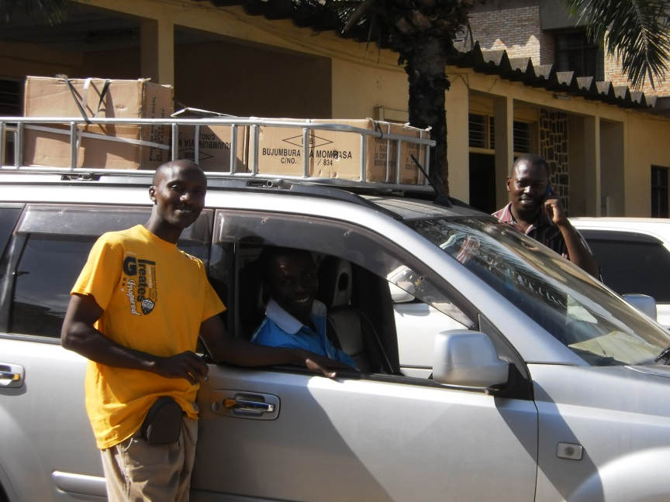

11 First Steps seminars
-The training seminars were mainly very well attended with around 50 – 300 pastors, evangelists & teachers attending each.
At first those who came where not sure what this new resource was?
It was only once they had attended and participated in the seminar that they understood and once they understood the course and how they could use it, they were truly delighted.
We received many delighted comments from pastors as to how excited they were to at last have a resource like First Steps in their own language of Kirundi. One pastor saying that this resource was so good, he was soon starting 2 new churches and would use this course to teach
all of the new believers.
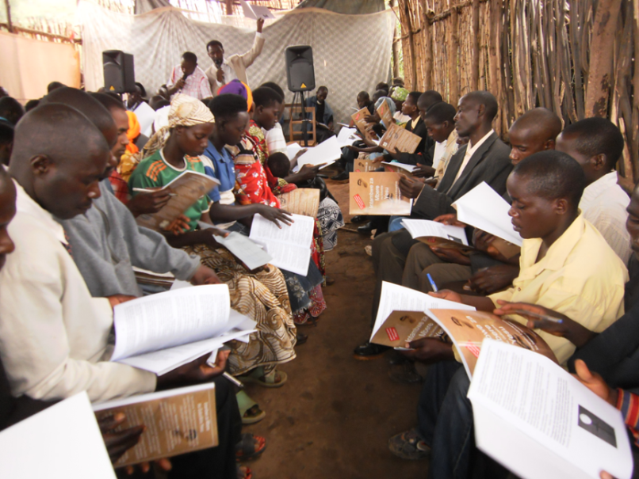
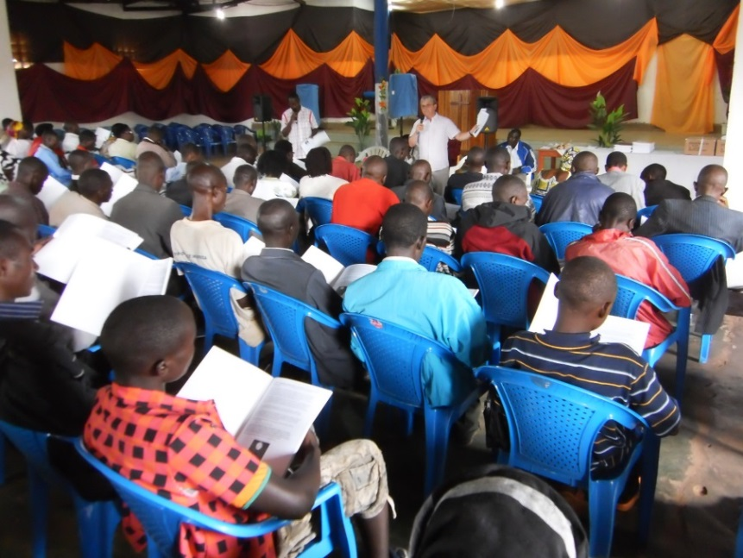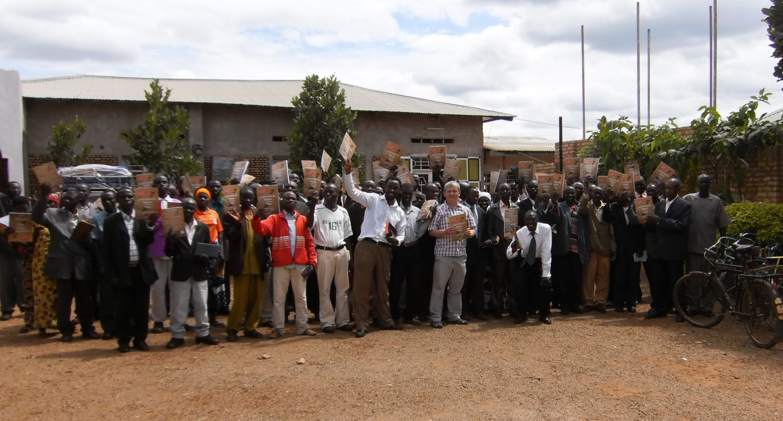
Bibles 4 Burundi
One of the big problems for the church in Burundi is a chronic lack of Bibles. Many people just cannot afford to buy a copy of God’s Word because they are just too poor and so typically around 90% of Christians do not have a Bible to love and read.
Your generosity has been so much appreciated and has enabled us to sell bibles at a significant reduction to the normal shop price. Just in the time of our short visit more than 300 bibles were sold at subsidised price and over 50 were given out free of charge to young people.
The need for God’s Word is great. Islam & secularism are growing rapidly in the country and the church needs to be equipped so that believers have a real basis of their faith based on the Word of God, rather than just music and worship.
We are now negotiating a working relationship with the Bible society in order to be able to offer Bibles on an on-going basis at half of the normal price. It is our prayer that this will enable many in poorer communities to have a realistic means to own a bible.
Your continued prayerful & practical support is vital and so much needed.
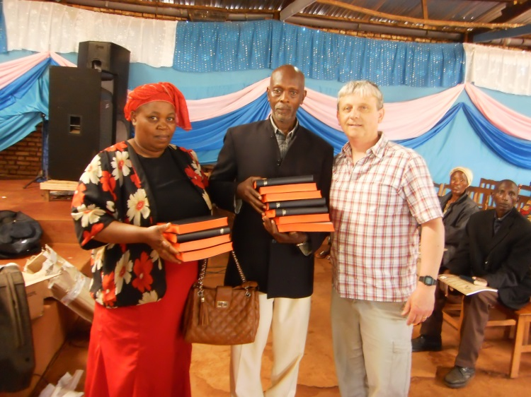
Thank you to all of you who have supported my visit and the continuing work of Young Ministry Group, either by prayer or in other practical ways.
Your support and encouragement has made this so possible and I thank each one of you.
In Jesus name,

Martin

